#LESSON PLAN
"This lesson introduces key spreadsheet skills, including cell referencing, basic calculations, and data analysis functions. You will learn how to use SUM, SUMIF, AVERAGE, MAX, and MIN to perform calculations and summarize data efficiently. Additionally, you will practice sorting data to organize information and gain insights from your datasets."

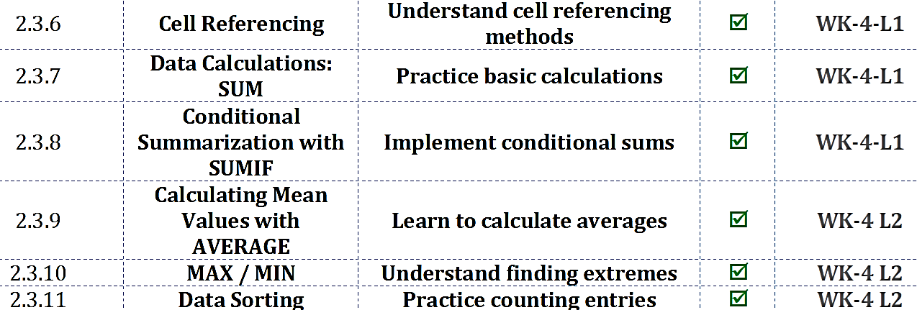

#STARTER
"Imagine you have a spreadsheet tracking your weekly expenses. How would you refer to a specific cell to use its value in a formula, and why might it be useful to copy that formula to other cells?

#2.3.6 Cell Referencing
Cell referencing is the method of referring to specific cells in a worksheet to perform calculations or analyses. It is important because it allows formulas to update automatically when copied, saving time and reducing errors. Relative cell references change automatically when a formula is copied (e.g., B2). Absolute cell references remain fixed using the $ symbol and do not change when copied (e.g., $B$2). Mixed cell references fix either the row or the column while allowing the other to change (e.g., $B2 or B$2). Correct use of these references ensures accurate and consistent calculations across datasets.
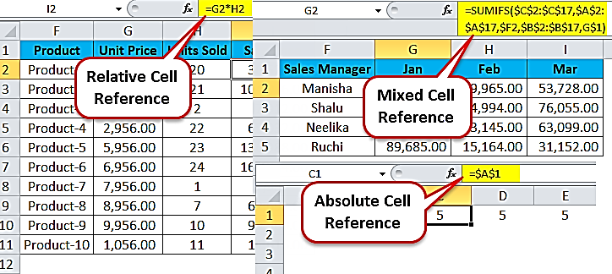

#Lab-WK-4-L1
"In this lab, you will practice using relative, absolute, and mixed cell references to calculate students’ final marks. You will start by adding test scores, then include a bonus value using absolute references, and finally explore mixed references for more flexible formulas. By the end, you will understand how different referencing methods affect calculations when copying formulas across a spreadsheet."

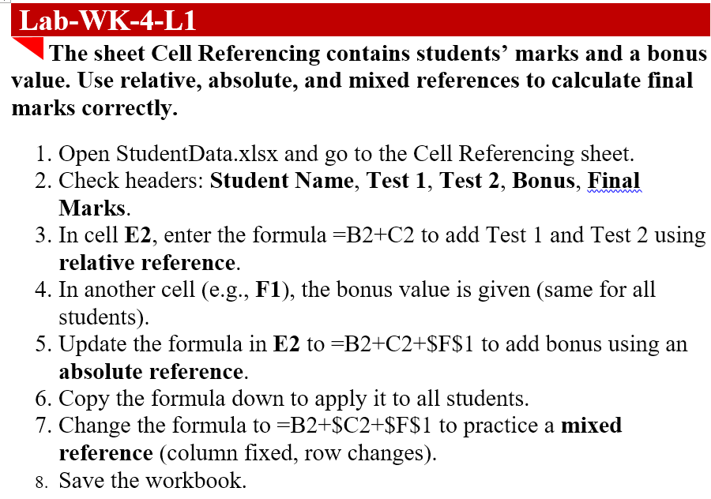

#2.3.7 Data Calculations: SUM
The SUM function is used to add values in a range of cells efficiently. It is important because it simplifies calculations, especially for large datasets, ensuring accuracy and saving time. Core concepts include summing rows, columns, or specific ranges, and combining ranges in a single formula.
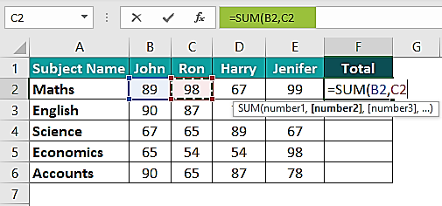

#Lab-WK-4-L1
"In this lab, you will practice calculating total sales using the SUM function. You will add monthly sales for each product and apply the formula across all rows. By the end, you will understand how SUM helps quickly total values in a spreadsheet."

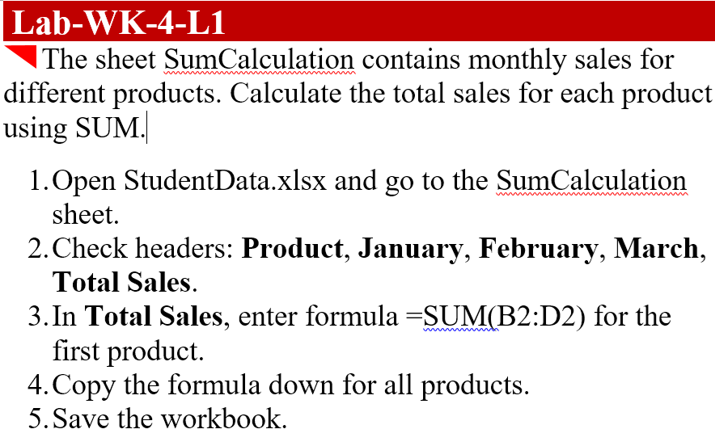

#2.3.8 Conditional Summarization with SUMIF
SUMIF allows summing of values that meet a specific condition. It is important because it enables targeted calculations, such as totals for a category or group, without manual filtering. Core concepts include defining the criteria range, condition, and sum range.
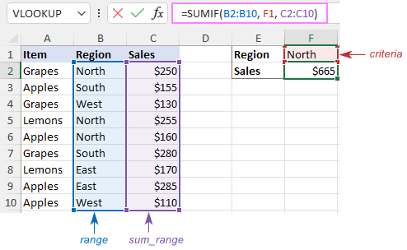

#Lab-WK-4-L1
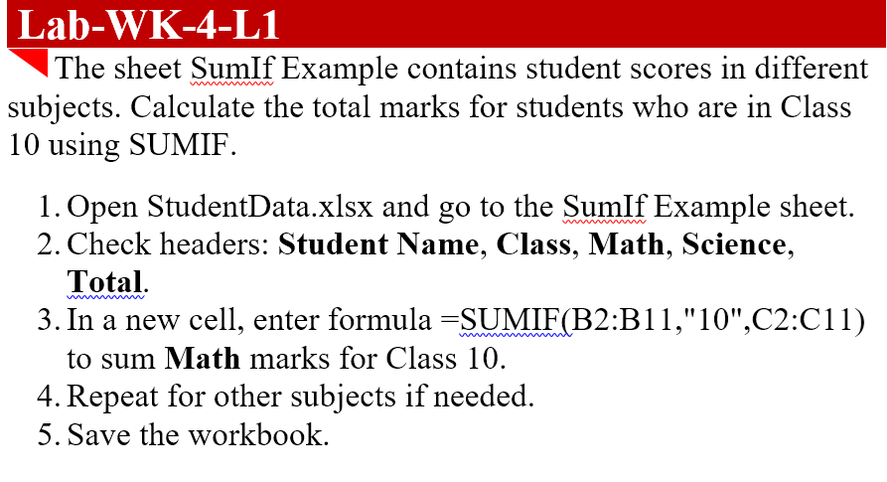
"In this lab, you will use the SUMIF function to calculate totals based on specific conditions. You will sum marks for students who belong to Class 10, allowing you to analyze data selectively. By the end, you will understand how SUMIF helps perform conditional calculations efficiently in a spreadsheet."

#2.3.9 Calculating Mean Values with AVERAGE
The AVERAGE function calculates the arithmetic mean of a set of numbers. It is important because it helps summarize data and identify overall trends or typical values. Core concepts include averaging ranges, ignoring blank cells, and combining multiple ranges.
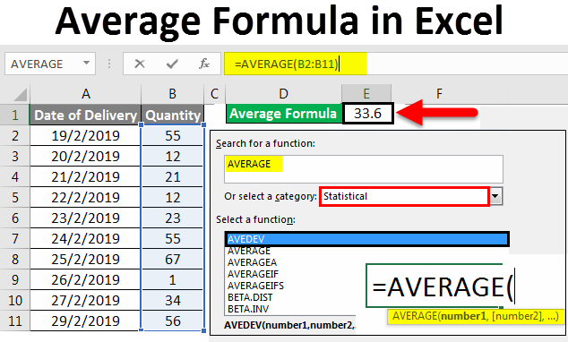

#Lab-WK-4-L2
The sheet AverageCalculation contains students’ scores for 3 tests. Calculate the average score for each student.

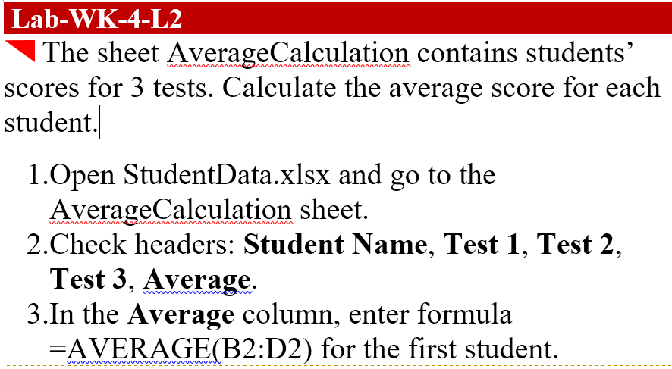

#2.3.10: MAX / MIN
MAX returns the largest value in a range, while MIN returns the smallest value. These functions are important because they quickly identify extremes in datasets, such as top scores or lowest sales. Core concepts include applying MAX/MIN to rows, columns, or ranges, and combining with other functions for analysis. They are commonly used in performance comparisons, rankings, and data validation. Using MAX and MIN helps detect outliers and understand the overall spread of data values.

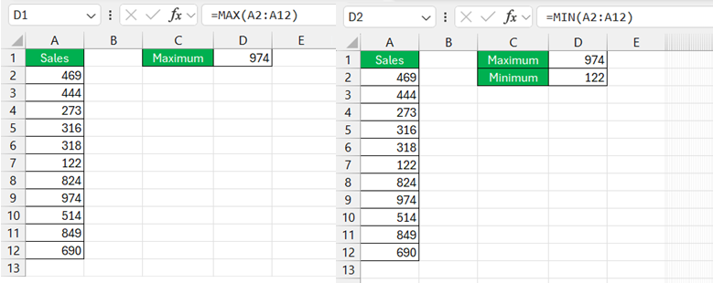

#Lab-WK-4-L2
The sheet MaxMinExample contains test scores for students. Find the highest and lowest scores in each test.

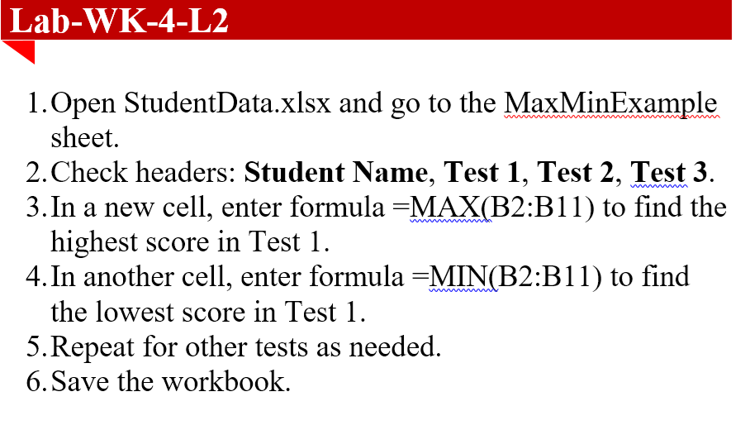

#2.3.11 Data Sorting

Data sorting is arranging data in a specific order, such as ascending, descending, or by custom criteria. It is important because it allows quick identification of trends, rankings, or patterns in datasets. Core concepts include single-column sorting, multi-level sorting, and sorting numerical or text data. Sorting helps prepare data for analysis and reporting.

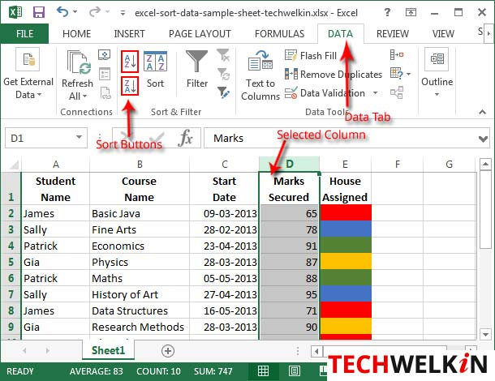

#Lab-WK-4-L2

The sheet DataSorting contains students’ scores and class information. Sort students by Class and then by total marks in descending order.

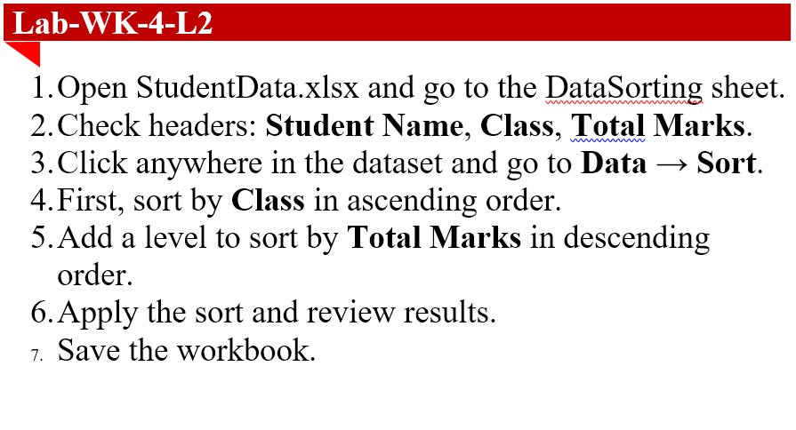

#Lesson Summary

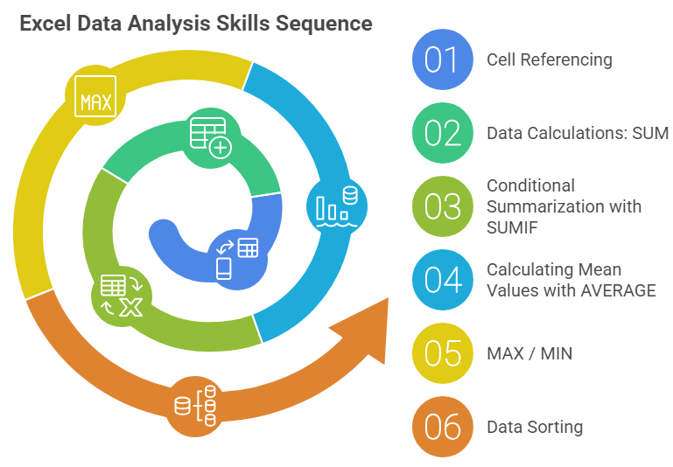
Cell Referencing enables formulas to dynamically link worksheet data using Relative, Absolute ($), and Mixed References, ensuring accuracy and reusability across datasets. Using references like =B2+C2 allows efficient calculation of totals while copying formulas with the Fill Handle maintains consistency. The SUM function simplifies adding values across rows or ranges, such as =SUM(B2:D2), saving time and reducing errors in large datasets. SUMIF supports conditional calculations by applying criteria, making it useful for grouped analysis like summing marks for a specific Class. The AVERAGE function calculates mean values to identify typical performance and overall trends while ignoring blank cells. MAX and MIN functions quickly detect highest and lowest values, helping identify extremes, rankings, and outliers. Data Sorting organizes information in Ascending, Descending, or Multi-level order to reveal patterns and rankings. Together, these tools support efficient Data Modelling, accurate analysis, and structured reporting in spreadsheets

